Abstract

Currency identification technology needs exploring and focusing on both visible and hidden flaws in paper money in order to build successful solutions. This is necessary so that effective arrangements may be developed. The Money Recognition and Change Framework is a tool that removes the need for human intervention in the process of recognising the whole monetary value of cash and converting it into other kinds of currency without the need for direct human supervision. The product interface that has been presented can be utilised for a variety of different monetary standards. There are several methods for obscuring or destroying cash notes, and a significant number of them integrate elaborate security measures. However, these methods are not foolproof. As a direct consequence of this, the procedure of identifying money becomes very challenging. As a consequence of this, it is extremely important to select the suitable components and do the required computations. Procedure, a less diversified nature, speed, and competence are the fundamental requirements that need to be met before a computation may be regarded implementable. Our fundamental purpose is to create a formula that is both straightforward and efficient, and which can be used to the recognition of a range of different monetary forms. It is not possible to build a single calculation that is capable of being utilised to recognise all accessible monetary forms since the various monetary forms each have their own unique set of security properties. It is also a time-consuming task to write a variety of different assignments for each individual student. The objective of the attempt is not to verify the various monetary forms but rather to recognise them.

Contents

1.1 Introduction 5

1.2 Basic Concept 6

1.2.1 MatLab 6

1.2.2 Image processing 7

1.2.3 Currency Region Extraction 8

1.3 AI in Currency Recognition 9

1.3.1 Digital image processing 9

1.3.1.1 Sampling and quantization 10

1.3.2 Neural Networks 10

1.4 Need 12

1.5 Application 13

1.6 Background Motivation 13

1.7 Problem Definition 14

1.8 Theoretical background 14

1.8.1 Image format 14

1.8.2 Currency Region Extraction 15

1.9 Technical background 15

1.9.1 Image pre-processing 15

1.9.2 Edge detection 16

1.9.3 Segmentation 16

1.9.4 Color 16

1.9.4.1 RGB 17

1.9.4.2 Grayscale 18

1.9.4.3 Others 19

1.9.4.4 The Method of Lightness 19

1.9.4.5 The Method of the Average 19

1.9.5 Histogram equalization 20

Chapter 2 21

Literature Survey 21

2.1 Introduction 21

2.2 Currency recognition and fake currency identification using image processing 24

2.3 Currency Recognition using Machine Learning 25

2.4 Fake Currency Recognition 28

2.5 Detection of Counterfeit Indian Currency Note Using Image Processing 29

3.1 Methodology 33

3.2 Currency Recognisation 33

3.2.1 Image Acquisition 34

3.2.2 Pre-processing 34

3.2.3 Conversion to Grayscale 35

3.2.4 Edge Detection 35

3.2.5 Image Segmentation 36

3.2.6 Feature Extraction and Comparison 37

3.2.7 Output 37

4.1 Results and Discussion 39

4.1.1 Relevant 44

5.1 Discussion 45

5.2 Conclusion 46

5.3 Future Work 47

References 48

***List of Figures***

Figure 1: RGB cube 17

Figure 2: Gray colour scale 18

Figure 3: A CNN for a image 25

Figure 4: Flattening of a 3x3 image matrix into a 9x1 vector 26

Figure 5: 4x4x3 RGB Image 27

Figure 6: Flow Chart of Currency Recognisation 33

Figure 7: Sierra Leonean Notes 37

Figure 8: GUI for project 38

Figure 9: Loaded currency notes 38

Figure 10: Edge Detection in algorithm 39

Figure 11: End result of recgnition 40

***List of Tables***

Table 1: Mean Intensity of RGB channel for different 500 note 40

Table 2: Banknote classification results 41

Table 3: Distinguish between currency and other image 41

Chapter 1

Introduction

# 1.1 Introduction

According to a national research, more than 150 different currencies are already in circulation throughout the world. The colour, size, and shape of these currencies vary greatly. Unlike in previous times, trade and commerce between nations has reached new heights. The requirement for banks to understand about practically all currencies has been critical. However, no human being can recognise or recollect all of the many forms of currencies that exist across the world. As a result, in the future, having an effective automatic system that assists in the detection of paper currency will be crucial. In this paper, we offer an automated system for currency recognition based on image processing techniques [1]. Our technology is compatible with the most commonly used currencies. It uses the provided image collection to accomplish object recognition. Paper dimensions, for example, vary, as do colour, pattern, and texture. Trade between countries has increased in recent years. Employees at Forex banks must be able to differentiate between various sorts of currencies, which is a challenging process. They must get acquainted with the numerous monetary symbols. Understanding currencies is therefore crucial. In any event, it is difficult for people to reliably recollect and recognise money. The real test is about to begin. As a result, recognising the money requires a computerised and automated method. We suggest a method for creating an automatic money identification system using machine-learning (image processing) [1] approaches. There are various currencies to choose from. We must guarantee that notes are appropriately polished while dealing with them in order to provide acceptable input to the system.

The note is entered into the system, which goes through many pre-processing phases before extracting the ROI (region of interest). We utilise ROI to detect the currency's origin first, and then we use ROI to calculate the denomination based on the note's size, colour, and text clipping. A "Currency Sorting Machine" aids bank staff in recognising various forms of money. The key operational steps of the "Currency Sorting Machine" are image capture and identification. It is a method of "optical, mechanical, and electrical integration" that integrates computer, pattern recognition (high-speed image processing), currency anti-fake technology, and a range of other multidisciplinary approaches. It is accurate as well as efficient. Most employees, however, must memorise a range of features and anti-fake labelling for numerous commonly used currencies. However, each of them provides a guidebook on the characteristics and anti-fake labelling of certain lesser-known currencies. Even so, no one can ever be assured that manual recognition is perfect. Otherwise, our system is built on image processing techniques including filtering, edge detection, segmentation [2], and so on. To finish the system, we'll need to create a small database to contain the currency's properties. In our system, we utilise the Sierra Leonean currency notes as examples. The system will be developed in MATLAB and have a straightforward user interface. The primary steps in the system are as follows:

1. Read the photo in JPEG format that we acquired from the scanner.

2. Image smoothing, noise reduction, and post-processing

3. Image processing, pattern matching, edge detection, and segmentation

4. The findings are printed.

Essentially, the pictures are drawn from a variety of sources. We do, however, have a technology that can read currency from a scanner. We don't need to buy a new equipment to put the system into action because the device needed is already in our homes. Face recognition and fingerprint recognition are two instances of recognition systems that are similar. Although their concepts are similar, their methodology and approaches are distinct.

# 1.2 Basic Concept

Every money in the world has a distinct look. The paper's size, colour, and design, for example, are all different. Workers at facilities such as money exchange offices must be able to distinguish between various types of currencies, which is a challenging process. They must remember the symbol for each currency. This might result in inaccurate recognition [3], thus they need a dependable and effective method to help them with their duty. The purpose of our system is to help individuals who need to distinguish between different currencies and function swiftly and efficiently. As a result of the expansion of modern financial services, automatic systems for paper cash recognition have grown more important in a variety of applications such as vending machines. Counting different denomination bills in a group is quite tough. This research presents an image processing approach for recognising and converting paper cash [3]. The extracted area of interest (ROI) may be matched using Pattern Recognition and Neural Networks.

## MatLab

MATLAB, which is an abbreviation that stands for "MATrix Laboratory," is a multi-paradigm programming language and quantitative computing environment that is exclusive to MathWorks [4]. MATLAB allows for the manipulation of matrices, the visualisation of functions and data, the implementation of algorithms, the creation of user interfaces, and the connecting of MATLAB with programmes written in other languages.

In spite of the fact that MATLAB's primary purpose is to facilitate numerical calculation, symbolic computing capabilities may be accessed through the use of an optional toolbox that makes use of the MuPAD symbolic engine. An add-on piece of software known as Simulink offers graphical multi-domain simulation in addition to model-based design for dynamic and embedded systems.

It is possible for MATLAB to call functions and subroutines that have been developed in the programming languages C or Fortran. It was decided to write a wrapper function that could both receive and return MATLAB data types. MATLAB executables, also known as MEX files, are dynamically loadable object files that are created whenever routines like these are generated. Since 2014, more Python interfaces with two-way communication have been introduced.

Many MATLAB libraries, such as the ones that provide support for XML or SQL, are designed as wrappers around Java or ActiveX libraries. MATLAB allows users to call libraries written in Perl, Java, ActiveX, and.NET directly from within the programme. It is more harder to call MATLAB from Java, but it is feasible to do so by utilising either a MATLAB toolbox that is sold separately by MathWorks or an undocumented method known as JMI (Java-to-MATLAB Interface). Both of these methods may be found on the MathWorks website (which should not be confused with the unrelated Java Metadata Interface that is also called JMI). 2016 saw the launch of the official MATLAB [4] Application Programming Interface (API) for Java.

## 1.2.2 Image processing

Digital image processing is the term given to the process of making changes to photos by utilising digital computers. The past several decades have seen a meteoric rise in the item's level of appeal. Processing geological data and performing remote sensing are two of its many applications, which also include medical and entertainment functions. Multimedia systems, which are dependent on digital image processing for the most part, are one of the pillars upon which the present information society is built. The field of digital image processing is rather wide and encompasses a variety of subfields, such as picture-specific techniques and digital signal processing methods. An image is a function, denoted by the notation f (x, y), that is defined using the two continuous variables x and y. Before it can be handled digitally, it needs to be sampled and transformed into a number matrix first. Because a computer can only accurately represent numbers to a certain degree, the numbers in question need to be quantized before they can be stored in digital form. The purpose of digital image processing is to achieve more accurate results by careful modification of the values that are available. Image enhancement, picture restoration, image analysis, and image compression are the four distinct subfields that fall under the umbrella of digital image processing. Picture enhancement is the process of modifying an image, most frequently via the use of heuristic methods, in such a way that a human observer is able to extract useful information from the image. Methods of image restoration are developed to deal with damaged photographs and typically contain a statistical or mathematical explanation of the degradation that may be reversed. This allows the process to be undone. The methods of picture analysis make it possible to analyse an image in such a way that information may be extracted automatically from it. Image analysis encompasses a wide variety of processes, including image segmentation, edge extraction, texture analysis, and motion analysis. The vast amount of data that must be gathered in order to accurately describe images is a crucial component [5]. Even a grayscale image with a moderate resolution, such as 512 pixels by 512 pixels, requires 512 pixels by 512 pixels multiplied by 8 billion two hundred thousand bits to be represented. As a consequence of this, in order to save and transmit digital photographs, some form of image compression is necessary. In this sort of image compression, the redundancy of the pictures is utilised in order to minimise the number of bits required in their representation.

## 1.2.3 Currency Region Extraction

Extraction of Currency Regions After our observations, we realised that the basic distribution is the same, with a head portrait on the right side and a white area on the left. The water mark is positioned in the left white region, with some inscriptions on top. The currency's value is distributed at the corner, and some additional patterns are dispersed in the nearly similar location of these two types of currencies. There are also some key traits that separate the various currencies [6]. The previous Chairman Mahatma Gandhi is shown in the head portrait. However, the value of the rupee varies depending on the person. Preprocessing of images Determine the currency type Fail Show re-create failure False Color recognition True Matching patterns 4 False The texts at the top are in two languages. The currency's value is spread along several diagonals. The silver thread is clear and wide. And the equivalent in is unobtrusive and narrow. These distinctions might be employed in our algorithm to get a more accurate result.

# AI in Currency Recognition

Machines may be trained to understand visuals in the same manner that our brains do, and to evaluate those images considerably more deeply. Face recognition and authentication capabilities powered by artificial intelligence may be used to ensure public safety, identify and recognise objects and patterns in photos and videos, and so on.

In general, image processing is the manipulation of a picture in order to improve it or extract information from it. Image processing can be done in two ways:

* Physical pictures, prints, and other hard copies of images are processed using analogue image processing.
* Digital image processing is the use of computer algorithms to manipulate digital pictures.

The input in both situations is a picture. The result of analogue image processing is always an image. However, the result of digital image processing may be a picture or information linked with that image, such as data on features, attributes, bounding boxes, or masks.

Image processing is now widely employed in fields such as medical visualisation, biometrics, self-driving vehicles, gaming, surveillance, law enforcement, and others. Here are some of the primary applications of image processing:

• **Visualization** — Represent processed data in an intelligible manner, for example, by providing visual form to items that aren't visible.

• **Image sharpening and restoration** — Enhance the quality of processed photos.

• **Image retrieval** — Assist with image search

• **Object measurement** — Measure things in an image

• **Pattern recognition** — Separate and classify objects in an image, identify their locations, and comprehend the scenario

## Digital image processing

The term "image processing" refers to a series of operations that are carried out on a picture in order to produce an improved version of the image or to derive some helpful information from it. It is a sort of signal processing in which the input is an image and the output might either be the picture itself or the characteristics or features that are connected with that image. Image processing is now one of the technologies that is expanding at a rapid rate. Additionally, it serves as a central research field for the disciplines of engineering and computer science.

In its most basic form, image processing consists of the following three steps:

Importing the picture by using image acquisition tools [7], analysing and altering the image, and producing output, where the outcome might be a changed image or a report that is based on the analysis of the image.

Image processing can be done in one of two ways: analogue or digital. Both of these technologies have their advantages and disadvantages. For the tangible copies, such as prints and pictures, the analogue image processing method can be utilised. While doing work with these visual approaches, image analysts apply a variety of interpretation principles from their toolkit. The digital image processing techniques allow for the digital pictures to be manipulated through the use of personal computers. When employing digital techniques, there are three main steps that all different kinds of data have to go through. These steps are known as pre-processing, augmentation, and presentation, and information extraction.

## 1.3.1.1 Sampling and quantization

It is necessary for the image function f(x,y) to undergo digitization in both the spatial and amplitude dimensions before it can be utilised in digital processing. The sampling and quantization of the analogue video stream is often performed with the assistance of a frame grabber or digitizer. Therefore, in order to make an image that is digital, we need to transform continuous data into the form of digital data. It is completed in two stages, which are Sampling and Quantization [8].

The spatial resolution of the digitised picture is determined by the sampling rate, while the number of grey levels in the image is determined by the quantization level. In image processing, the magnitude of the sampled picture is converted into a digital value and then processed. Quantization [8] refers to the process by which the picture function makes the shift between its continuous values and its digital equivalent.

It is essential that there be a sufficient number of quantization levels for human beings to be able to perceive subtle shade nuances in an image. The most significant issue that arises in a picture after it has been quantized with inadequate levels of brightness is the appearance of spurious outlines.

## 1.3.2 Neural Networks

The usage of neural networks is beneficial to artificial intelligence, machine learning, and deep learning because it enables computer programmes to recognise patterns and discover solutions to common issues. The functioning of the human brain may be analogized by neural networks. Deep learning techniques are based on neural networks, which are a subfield of machine learning and an essential component of the latter. In certain circles, they are also referred to as artificial neural networks (ANNs), whereas in others, they are called simulated neural networks (SNNs). Their structure, which mirrors the way that real neurons interact with one another, took its name and its inspiration from the human brain, which also served as an influence for their structure. Node layers are the fundamental constituents of artificial neural networks (often abbreviated as ANNs for short). One or more hidden layers, in addition to an output layer, are included in these layers. Also included is an input layer. Each node, which is often referred to as an artificial neuron, is connected to another node and is associated with a weight and threshold value. If the output of one particular node is greater than the value that has been determined to be the threshold for activation, then that particular node will become active and will begin passing data to the subsequent layer of the network. This threshold value has been determined to be the value that must be greater than the output of one particular node in order for activation to occur. In the event that this requirement is not satisfied, the data will not be sent to the next level of the network. Training data are required for neural networks in order for the networks to be able to learn and improve their level of accuracy over time. However, once these learning algorithms have been fine-tuned for accuracy, they become powerful instruments in computer science and artificial intelligence [10], which enables us to categorise and cluster data at a high velocity.

This paves the way for a great deal of new research prospects. It may only take minutes rather than hours to complete jobs involving speech recognition or image identification, in comparison to the amount of time it takes human experts to manually identify anything. One of the neural networks that has achieved the greatest renown is Google's search algorithm, which is also one of the most famous. Following the conclusion of the analysis of each input layer, the weights are subsequently assigned. Greater weights contribute more substantially to the outcome in compared to the other inputs, and these weights help determine the relevance of any single variable by contributing to the determination of that variable's importance. After that, each of the inputs is multiplied by its own weight, and then the products that are generated are combined with one another. After that, the output is input into an activation function, which in the end is accountable for deciding what the output will be. If the output of the node is larger than the predefined threshold, the node is "fired," which indicates that data is sent on to the subsequent layer of the network. This occurs when the output of the node is greater than the threshold. As a direct result of this, the information coming out of one node will be incorporated into the information coming into the next node. A feedforward network is a form of neural network that gets its name from the act of passing input from one layer to the next. This process gives the network its common moniker of a feedforward network. Different forms of neural networks are:

There are an infinite number of distinct forms that neural networks may take, and each one is optimised to perform a unique task in accordance with that shape. The following is not a complete list of the types of neural networks; nonetheless, these are typical examples of the most prevalent kinds of neural networks that you'll come across while working with its popular use cases:

The perceptron was the world's first neural network, and it was first designed by Frank Rosenblatt in 1958. It is the most fundamental form of neural network, as it contains only a single neuron, and its functions are as follows: A basic illustration of a perceptron created in blue using lines and a circle.

The majority of our focus has been placed on feedforward neural networks, which are also referred to as multi-layer perceptrons (MLPs). An input layer, one or more hidden layers, and an output layer are included in the construction of each of these layers independently. In spite of the fact that these neural networks are also usually referred to as MLPs, it is vital to highlight the fact that in actuality, they are composed of sigmoid neurons and not perceptual [11].

This is due to the fact that the overwhelming majority of problems that occur in the actual world are of the nonlinear variety. These models are frequently trained by having data injected into them, and they serve as the foundation for other neural networks, in addition to natural language processing and computer vision. CNNs, or more often known as convolutional neural networks, are extremely similar to feedforward neural networks; however, rather than being used for pattern identification, CNNs are primarily employed for image recognition and computer vision. These networks make use of techniques from linear algebra, namely the process of matrix multiplication, in order to recognise patterns that are included inside an image. This allows the networks to accomplish their goal of pattern recognition. [12] Recurrent neural networks, often known as RNNs, are distinguished by the presence of feedback loops in their architecture.

These learning algorithms are most typically used when utilising time-series data to produce predictions about future events, such as stock market forecasts or sales forecasts. Examples of this type of prediction are sales forecasting and stock market forecasting. The forecasting of sales and projections made regarding the stock market are two examples of this.

# 1.4 Need

Those who need to be able to differentiate between various currencies in order to carry out their work in a rapid and effective manner are the target audience for our system. Because there are more than 180 distinct currencies used in different parts of the world. It is tough to recognise and keep track of the many currencies. People could remember something for a shorter amount of time before they forget it. As a consequence of this, there is a potential for complications in businesses in which individuals deal with a number of different currencies. As a result of this, we presented an automatic method that, without the need for human intervention, can correctly determine the name of the money, where it originated, and how much it is worth.

# 1.5 Application

Currency identification software is useful in a variety of contexts, including financial institutions and enterprises that deal in the exchange of currency. The evaluation or the use of the project that was provided may be used to evaluate whether or not a project is relevant. The relevance of a project reveals how effective the project's result is. That is to say, the relevance of a project must always be linked to some goal in order for it to be considered relevant. In the case of general research projects, this goal is typically an advancement in scientific knowledge; however, it may also be linked to more immediate social and environmental advantages for our society. The detection of counterfeit currencies [13], which are often utilised in the Indian market, is the primary emphasis of our work with regard to this proposed system. A secondary goal of ours is to utilise image processing techniques in order to differentiate authentic cash from counterfeit currency. The importance of our work can be compared to that of a system that can identify different types of currency using neural networks. Banknotes are analysed in this piece so that robust features may be identified and extracted. The majority of people still recognise cash by hand, despite the fact that several technologies for recognising currency have been invented in recent years. This fact is commonly misconstrued by various individuals. Building a system that is capable of recognising all forms of currency and is beneficial to the average person is the end objective of constructing a system with the purpose of producing a system that can recognise all forms of currency.

# 1.6 **Background Motivation**

The need for an automatic currency recognition system has increased in recent years as a consequence of the fact that there are more than 150 different currencies in circulation around the world. The requirement to construct a system for processing notes with minimal input from humans for a range of objectives was the impetus behind the development of a system that helps in recognising or identifying paper notes. This was done for a variety of reasons. This duty takes on a much greater level of significance as a result of the variations in the physical characteristics of each note and the distinct safeguards implemented by each currency [14]. In order to design a system that makes use of a technique for cash detection and identification, a variety of construction methodologies, such as pattern matching, have been described here. The issue is still an intriguing one, especially considering that there is not a single approach that has been established as being enough for significant progress. At the beginning of the 1990s, a suggestion was made to make use of image processing tools in order to identify paper currency. It is believed that the notes that were taken are in good form, and the photographs are obtained whenever they are required. It is essential to keep in mind that the procedure that is advised calls for the submission of images that were taken in specific proportions. The proposed method begins by subjecting the input images to a number of stages of preprocessing. Afterwards, many characteristics are selected as hue, saturation, and value criteria in order to calculate Euclidean distance using these parameters. The results of this calculation are then compared to the parameters that were specified as being used as standards. Even though an algorithm for a number of different currencies was devised as part of this system, it was difficult to apply due to the different types of notes used in different countries.

# 1.7 Problem Definition

The concept of building a currency recognition system is the foundation of this project's core idea. Because every nation has its own currency, it can be challenging for individuals to understand one another's. The manual currency identification process has a number of problems that need to be addressed. This system is going to be designed so that we can handle the problems that have recently come up.

# 1.8 Theoretical background

A scanner, a computer, and an algorithm are the components that make up the system. The one-of-a-kind figure, which comprises RGB to Gray conversion, image binarization, noise reduction, segmentation, pattern matching, and so on, is where the help for the algorithm can be found. This is something that we are able to accomplish thanks to the programming language MATLAB®.

## 1.8.1 Image format

JPEG is used to format the picture we acquire from the scanner. JPEG (Joint Photographic Experts Group) is a standard for digital picture destruction or loss compromise. When you save an image as a JPEG, certain information is lost, which cannot be retrieved.

## 1.8.2 Currency Region Extraction

As a result of our investigations, we found that the fundamental distribution, which consists of a head portrait on the right side and a white area on the left, is the same regardless of whether the currency being used is SEK or RMB. The watermark may be seen in the white space on the left, and certain inscriptions can be found on top of it. The position of the value of the currency is shown to be distributed in the corner, and other patterns are shown to be distributed in the nearly same region of the two different types of currencies. There are also certain characteristics that set each of the different currencies apart from one another. Mao Zedong, the former Chairman of China, and the figure shown on the head of the RMB are one and the same person. On the other hand, the SEK might be very different depending on who you question about its value. The most effective texts are those that are written in a minimum of two languages. The positions of the currency's values are all allocated along the diagonals in a different way. A transparent and extensive silver thread may be seen for SEK. And the equivalent in RMB is unremarkable and restricted in its scope. These discrepancies may be included into our system in order to assist us in achieving a more precise outcome.

# 1.9 Technical background

The most important methods implemented by this system are picture analysis and image processing, both of which are subfields of cognitive science and computer science respectively. Image processing ultimately devolves into signal processing once preprocessing has been completed. It's possible that the result will be a picture, or it may be a collection of image-related traits or characteristics. In point of fact, the image is treated as if it were a two-dimensional signal and processed using both conventional signal processing techniques and image processing techniques at the same time. Image analysis is a method that primarily utilises digital image processing techniques to extract useful information from digital photos. This information may then be used in many applications. The tasks involved in image analysis might be as straightforward as reading barcodes on tags or as involved as identifying a person solely based on their appearance. Image preprocessing, edge detection, segmentation, and pattern matching are some of the techniques that need be included in the system in order for it to be able to identify different types of cash.

## **1.9.1 Image pre-processing**

Image pre-processing is utilised for activities on images that are performed at the most fundamental level of abstraction. If entropy is used as a measure of information, then pre-processing will not improve but rather reduce the amount of information contained in an image. For instance, histogram equalisation modifies the brightness [3] and contrast of the picture, which results in the image appearing to have more clarity. One further illustration would be the elimination of picture noise and the enhancement of edge recognition quality (image).

## **1.9.2 Edge detection**

Edge detection is a technique used in image analysis to locate the borders of different regions. Edges and contours are extremely important aspects of both human vision and the vision of a great number of other biological organisms. Not only do edges have a pleasing aesthetic, but they may also be utilised to either define or reconstruct the entirety of a form.

## **1.9.3 Segmentation**

The process of segmentation is often considered to be among the most important elements of image processing. Its purpose is to partition an image into sections that may be reliably associated with certain items [3]. We need to make use of it so that we may divide the functionality of our project into separate sections.

## 1.9.4 **Color**

The human ability to differentiate colours is a fundamental component of our visual experience. The RGB or HSV colour model is the one that will be used when transmitting or displaying colour by the majority of devices. When it comes to computer graphics, the RGB paradigm is most often utilised as the basis for a colour space. Image creation is accomplished by the use of the RGB colour model, which is an additive colour model that makes use of the primary colours red, green, and blue. It is possible to see the primary spectral components that make up each colour. Despite the fact that the RGB colour model is most commonly used in electronic systems for image detection, representation, and display, it has also been used in conventional photography. When selecting colours from a colour wheel or palette, one of the many colour systems that people use is the HSV model, which can be seen in Figure 4. The HSV model is only one of many colour systems. This colour model is quite a little more accurate than its predecessor.

HSV is an abbreviation that stands for the terms "Hue, Saturation, and Value." The degree or percentage of a color's saturation can be used to represent its hue. Hue is a measurement of colour purity. The radius of the circle is represented by saturation. The number one, often known as value, is used to signify "perfect white" (R = G = B = 1) as well as any colour that is entirely saturated. The colour spectrum for grey extends from black to white and everywhere in between [15]. The combination of these two colours results in the creation of grey paint. A single sample consists of the value that is assigned to each pixel in a grayscale image.

In many different types of applications, it is required to first represent colours as numerical values. In order to accomplish this, we make use of models, which are essentially mathematical models that explain various ways of mapping colours to a collection of integers. In most cases, a colour model will identify three or four colour components, each of which may be simply defined using a coordinate system. This particular coordinate system assigns a value, or point, to each colour that the model is capable of representing.

These models not only contain the values for the components, but also a description of how to interpret those values in order to produce a colour from the components.

## 1.9.4.1 RGB

RGB, which is an abbreviation that stands for "Red-Green-Blue," is the most well-known colour model. This model depicts colours by assigning separate values to the red, green, and blue components, as the name of the model implies. The RGB model is utilised in virtually every digital screen that exists around the globe.

To be more specific, the definition of a colour is determined by utilising three integer values ranging from 0 to 255 for red, green, and blue. A value of 0 indicates a dark colour, while a number of 255 indicates a brilliant colour. When we blend these three primary colours while giving consideration to their respective values [16], we arrive at the ultimate colour that we are looking for. If we mix the three colours together in an equal amount, we will get white (RGB = (255, 255, 255)), whereas black is represented by the absence of all colours (RGB = (0, 0, 0)). The RGB colour coordinate system can be seen down below, and it displays all of the many colours that the model is capable of describing:

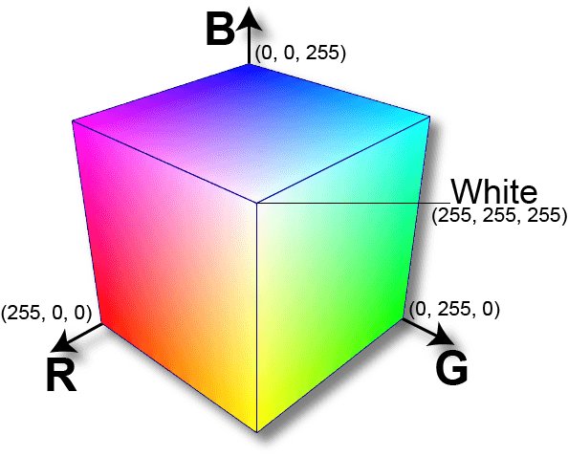

Figure 1: RGB cube

## 1.9.4.2 Grayscale

The grayscale model is the simplest one since it only relies on one aspect to describe colours, and that aspect is lightness. A number that ranges from 0 (black) to 255 (white) is used to express the degree of brightness present (white).

Grayscale photographs, on the other hand, carry less information than their RGB counterparts. However, grayscale images are rather prevalent in image processing since it is faster and needs less space to store a grayscale image than an analogous colour version, which is especially helpful when dealing with complex computations.

The whole spectrum of colours that may be described by the grayscale model is presented in the following image:

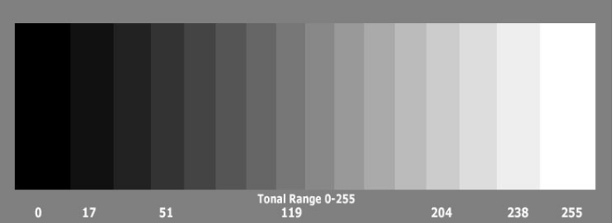

Figure 2: Gray colour scale

## 1.9.4.3 Others

Throughout the years, several different suggested models have been developed, each one catering to a certain use case. Printing, for instance, makes use of the CMYK model, which represents colours by assigning values to the hues cyan, magenta, yellow, and black respectively. HSL and HSV are two colours that artists utilise because they are more aligned with the way human eye perceives a colour. Artists employ HSL and HSV because of this alignment. The hue, the saturation, and the brightness or value, depending on the context, are the fundamental components.

**Convert RGB to Grayscale**

Now that we've gotten that out of the way, let's discuss the most important aspect of this guide, which is how to change a picture from RGB to grayscale. As a result of the fact that these models are predicated on various interpretations of colour perception (basic colours and brightness), there is no one conversion method that is 100% accurate. There are a few popular approaches, such as the ones that are listed below.

## 1.9.4.4 The Method of Lightness

Taking the average value of the components that have the greatest and lowest value is a relatively straightforward approach that may be used:

Because one of the RGB components is not being utilised, it is immediately clear that this approach has a major flaw that might have very catastrophic consequences. Due to the fact that the degree of brightness that our eye sees is dependent on all three primary hues, this is unquestionably a problem.

## 1.9.4.5 The Method of the Average

Another approach is to determine the value of the grayscale by averaging the values of the three components (red, green, and blue):

Even if we now take into account all of the components, the average technique is still flawed since it gives equal weight to each of the components. According to the findings of several studies on the human visual system, we are aware that our eyes have a unique response to each hue. To be more specific, human eyes are most sensitive to the colour green, followed by the colour red, and then the colour blue. Because of this, the weights in the previous calculation need to be adjusted.

## 1.9.5 Histogram equalization

Histogram equalisation is a method for changing a photograph's contrast that is based on the histogram of the image. This approach works wonderfully for pictures that include both light and dark elements in the foreground and the background.

When the useful data of an image is represented by values of near contrast, this approach will often improve the global contrast of the picture. Because of this, regions that previously had a lower local contrast are now able to attain a greater contrast. The amount of pixels that are comprised of each distinct colour component may be deduced from an image's colour histogram. It is impossible to apply histogram equalisation independently to the Red, Green, and Blue [17] components of a picture since doing so would result in significant shifts in the colour balance of the image. However, if the picture is first converted to a different colour space, such as the HSL/HSV colour space, then the technique may be applied to the luminance or value channel of the image without causing changes to the image's hue or saturation.

# Chapter 2

# Literature Survey

# 2.1 Introduction

A strategy based on image processing was proposed by Jain et al. [1] to extract the quantities of paper currency used in the survey. Methods of matching based on Pattern Recognition and Neural Networks can be utilised in order to match the obtained ROI. They begin by obtaining the photograph by means of a straightforward flat scanner operating at a fixed dpi and a certain size. After that, they organise the pixel level in order to obtain the image. A note needs to go through a few different filters before its denomination can be determined. They make use of a variety of pixel levels, depending on the amount notation. In their work, Mirza and Nanda [2] presented a method for establishing the legitimacy of Indian paper currency. This method includes four characteristics of paper currency, as well as an identifying mark, security thread, latent image, and watermark into its system. It is possible that the system will be able to extract the concealed attributes of the paper currency, such as the secret picture and the watermark. In the study that has been proposed, an attempt will be made to provide a mechanism for determining the qualities of Indian paper currency. [3] Chakra Borty and colleagues provided a detailed analysis of studies on a wide spectrum of advancements in the classification of money denominations during the past many years. In order to evaluate the current state of the art, a range of study approaches that have been applied by a number of different researchers are briefly described. The author of this paper devotes a significant amount of attention to a currency identification system. This system consists of a number of steps, such as the capture of pictures, the extraction of features, and the classification using a variety of algorithms. In their research, Reel and colleagues [4] revealed how to recognise Indian cash by using a heuristic analysis of the characters on the notes as well as a number of the serial numbers on the notes. It is necessary to extract feature descriptors from an image in order to be able to discern a character from a particular picture of cash. Because the quality of the entire OCR process is influenced by the extraction approach, it is essential to extract features that are invariant to varied light circumstances, font type, and character deformations induced by picture distortion. This is because the quality of the OCR process as a whole is influenced by the extraction approach. Because of this, prior to the process of feature extraction in currency identification, heuristic character analysis is conducted in order to acquire the specific qualities of the characters.

Pawade et al. [5] focused their review on the various methods and systems that are now available for the recognition of currency based on image processing. They kept the processes for recognising paper currency and inventions completely distinct from one another. In the end, they presented their findings in a tabular manner, which enabled the information to be quickly absorbed by the reader. In spite of the significant amount of research that has been conducted on this subject, there are still a few challenges about the accuracy and effectiveness of the procedure. As a consequence of this, it will always be difficult for academics to achieve maximum efficiency and one hundred percent accuracy for heterogeneous money when the physical state of the currency is not in such good shape. There are a variety of currencies that can be accessed in every region of the world, and the need for automated systems that are combined with currencies is quickly growing. During the procedure, the system must be designed in such a way that the currency note can be easily detected and recognised without the participation of a human being in either step. Despite the possibility that the course of each note may change, it is vital to carry out this operation because of the built-in safety provisions of the various currencies. Approaches that had been suggested in the past took into account factors like the aspect proportion and the HSV merit. There were methods that employed a single algorithm for the processing of each of the available cryptocurrencies. In any event, the fact that even a single technique has proved that the system is effective for development makes this an intriguing field of study to look further. Early methods for recognising currency notes using image processing techniques in the early 1990s did not take into account the perspectives of note verification since these viewpoints were not taken into account. As a consequence of this, it is presumed that the currencies are in satisfactory operating condition and that the images comply with the requirements. It is essential that you take into consideration the fact that the proposed system calls for the input photographs to be processed in a predetermined sequence. In order to compute a distance that is known as the Euclidean distance, the computer system performs a number of pre-processing stages to the input and produces fixed characteristics such as hue, saturation, and merit variable. In addition, the computer system also calculates the Euclidean distance. Utilizing these criteria, you can do a comparison between the confirmed note values and the standard values. In spite of the fact that this method enables us to propose a step-by-step process for the currencies of other nations, it is an inefficient technique for recognising currency notes from countries with features that are comparable to those of other countries. In the study that was done [7], an approach was developed in which the system would establish predefined characteristics of the notes and then estimate those features utilising standard values from the sql database in order to recognise the money. This method takes into account a large number of factors, such as the dimensions of the currency, and employs techniques such as edge detection (Canny) to obtain the other variables required to compute the Euclidean distance. In any event, the approach takes into account the dimensions of the currency.

In order to verify the authenticity of the paper under transmitted light, a linear array of photodiodes and phototransistors are placed on opposite sides of the currency paper. The most important information is printed on the uppermost surface of the money paper. A comparison is made with the data that is already there in order to validate the currency. The objective of this piece of writing is to determine whether or not the currency in question is real. It is modelled after the money used in Bangladesh. Because of advancements in technology, the production of counterfeit banknotes is now entirely feasible. As a direct consequence of this, image processing is utilised in order to validate the legality of the money. It can also convert photos, segment images, extract features, and match patterns. It also has the ability to smooth images. The detection of counterfeit currency is the major objective of the system. Individuals who want assistance in recognising the unique qualities of various currencies have access to a number of technologies that can do so. However, most staff working in currency exchanges are required to recall a range of features and anti-fake labels for many of the currencies that are routinely used. On the other hand, everyone has a handbook that details the qualities and anti-fake tagging of the currencies that are used the most. The accuracy of manual recognition can never be established with absolute certainty. As a consequence of this, our objective is to identify currency with a high degree of precision and with as little interference as possible. In addition, the proposed approach would speed up the detection of counterfeit cash, which will result in time savings [9]. Currently available options make use of an optoelectronic device to produce a signal from the light that is refracted by the banknote. Currently available on the market are a wide variety of money identification devices that are able to identify currency by employing various image processing techniques or neural network algorithms [9]. Image processing techniques and neural networks are the primary pillars on which the current generation of money detection systems is founded. Some systems use a Gaussian function in the hidden layer and the NN output layer rather of a sigmoid function. This is done in place of the sigmoid function. It has been established that the Gaussian function is superior to the sigmoid function when it comes to recognising recognised traits and rejecting unexpected ones [10].

# 2.2 Currency recognition and fake currency identification using image processing

An intelligent system for the identification of paper cash is being created, which is necessary for the development of currency automation systems. This system inspects 110 different photos. The image has a mixed collection of normal, noisy, and mixed images as part of its data set. These normal, noisy, and mixed images each have their own unique characteristics. This piece of writing asserts that its correctness is 91.65 percent. The outcomes produced by using this method are quite satisfying. Image capture, processing, feature extraction, comparative analysis, and outcomes are the phases that make up this process. [1] Identifying various currencies is a challenging process since each coin has a unique colour, design, size, and other characteristics. This system makes use of image processing, which consists of picture filtering as well as edge recognition and filtering. It does this by establishing the saturation and threshold for recognition, which gives it currency in HSV components. [2] This algorithm makes advantage of several essential characteristics that are derived from the physical note of cash. The algorithm makes use of both of the photos. The first one is the prototype for the paper money, and the second one is used to validate the cash that has to be checked. Five different currencies—the Rupee, the Australian Dollar, the Euro, and the Rial—have been validated by this piece of research. It functions flawlessly for all notes with the exception of the United States dollar.

The banknotes of the United States Dollar are unique to each denomination, making it challenging to identify them. [3] There are many different currencies that may be obtained in different parts of the world, and the requirement for an automated system that is connected with the various currencies has been rapidly expanding. During this phase of the process, the system has to be designed such that the currency note can be readily identified and recognised without the assistance of a person. Despite the fact that the future of each note is uncertain, the complexity of the security measures that are entangled in the many currencies make this effort extremely important. Different aspects, such as aspect proportion and HSV merit, were taken into consideration by the methods that were offered in the past. There are approaches that were developed that make use of a standard algorithm for each of the obtainable monetary systems. Even if just one approach was used, it was enough to demonstrate that the system was effective for development, which is one of the reasons why this topic is such an interesting one for research. The earliest approaches that were developed in the early 1990s to identify currency notes via the use of image processing techniques, such methods do not take into consideration the perspectives of verification of the notes. As a consequence of this, it is presumable that the currencies are in the appropriate state and that the intended photos have been produced. It is important to point out that the recommended system must take input photographs in a certain way since this is a crucial need.

In order to calculate a distance known as the Euclidean distance, the computer system performs a series of pre-processing steps on the input and generates fixed characteristics such as hue, saturation, and merit variable. With the assistance of these qualities, compare the merits of the confirmed note with the values that are considered standard. Even if this method enables us to suggest a step-by-step approach for the currencies of various nations, it is not an effective method for recognising the currency notes that are used in countries that share comparable characteristics. In the article [2], a method for identifying currencies is dissected, in which the system generates predefined characteristics of the notes and estimates those characteristics using the standard values found in the sql database. This technique takes into account a large number of variables, such as the dimensions of the currency, and also performs certain techniques, such as edge detection (Canny), to get other variables, which helps to calculate the Euclidean distance. In whatever way, this technique does so, it considers the dimensions of the currency.

# 2.3 Currency Recognition using Machine Learning

The concept of recognising different types of cash through the use of image processing is presented in this work. This method is successful because it takes into account three aspects—color, size, and texture—when performing the identification process. The method that is described in this research is capable of identifying the monetary systems utilised in a variety of nations. Only Indian paper currencies [18]., for the sake of ease of implementation, are taken into consideration. Because of this approach, checking the value of cash at any time and in any location is more simpler, and the procedure is carried out with the help of CNN (Convolution Neural Network). We put our technique to the test on all of the different denominations of Indian currency, and the system was accurate 95 percent of the time. In order to improve the reliability of the method, a classification model is developed that takes into account all of the relevant criteria. The characteristics of the paper currency play a significant influence in this recognition.

The method of image processing serves as the foundation for the project paper. This project's goal is to be able to distinguish between different denominations of paper money. The Tflite model and the teachable machine are essential components of the projects since they enable the creation of a categorised model for the project. In addition, we have utilised the CNN classification method in the process of carrying out the classification. The procedure that was subsequently followed by the capture of cash, and finally recognising output in the form of speech [18].. The model that was developed functions not only as a recognizer but also as a calculator since it adds up all of the denominations of cash that it identifies, so relieving us of the need to add them by hand.

CNN

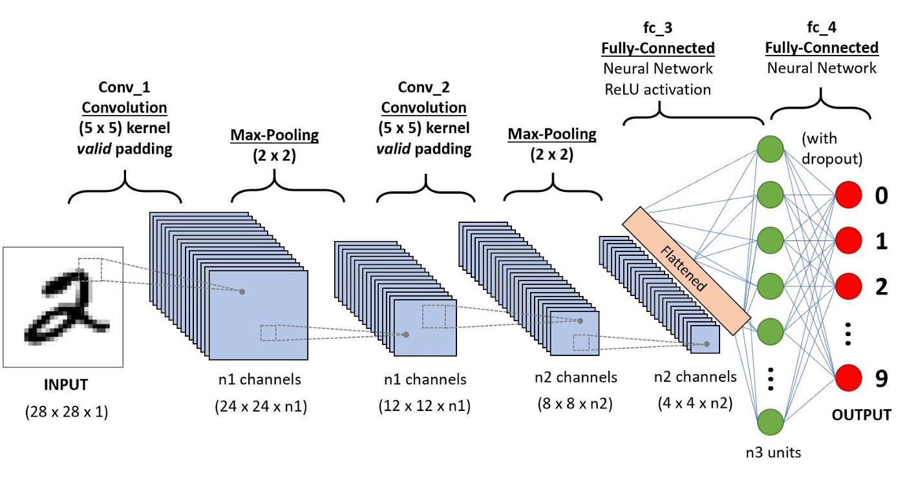

Figure 3: A CNN for a image

A Convolutional Neural Network, more commonly referred to as a CNN, is a type of Deep Learning algorithm that can take in an input picture, assign significance (learnable weights and biases), and differentiate between a variety of characteristics and objects that are contained within the image. CNNs are often referred to as "convolutional neural networks." When compared to the amount of pre-processing work required by other classification methods, the amount of work required for a ConvNet is greatly reduced. ConvNets have the capability, with adequate training, to learn these filters and attributes on its own given sufficient data, in contrast to the fundamental approaches, which need hand-engineering of the filters.

The architecture of a ConvNet was conceptualised after being inspired by the way neurons in the human brain are connected to one another, and the design of a ConvNet [19] is very similar to this pattern of neuronal connection. A certain region of the visual field is referred to as the "receptive field," and it is the only location at which individual neurons will respond to stimuli when they are presented with them. A collection of fields that overlap one another completely covers the area that is visible to the human eye.

.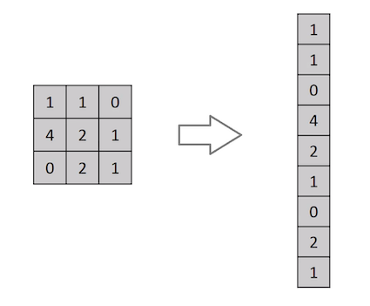

Figure 4: Flattening of a 3x3 image matrix into a 9x1 vector

For the sake of classification, why not just flatten the picture (for example, convert a 3x3 image matrix into a 9x1 vector), and then send it to a Multi-Level Perceptron? Um, no, not really at all.

The approach may have an average precision score when predicting classes for relatively simple binary pictures, but it would have very little to no accuracy when it came to predicting classes for complicated images that had pixel dependencies throughout.

By applying the appropriate filters, a ConvNet is able to properly capture the spatial and temporal relationships present in a picture. This is accomplished through the use of deep learning. Because to the decrease in the number of parameters involved and the reusability of the weights, the architecture achieves a better fitting to the picture dataset. To put it another way, the network may be taught to better comprehend the level of complexity present in the image.

Input Image

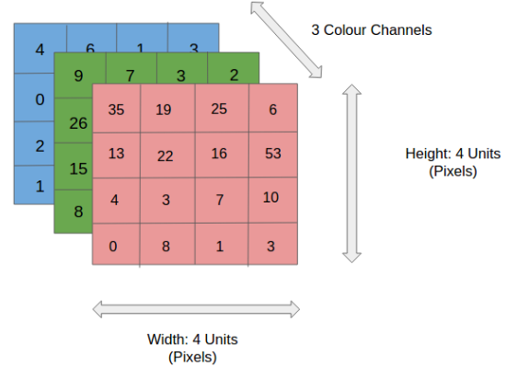

Figure 5: 4x4x3 RGB Image

An RGB picture that has been segmented into its individual red, green, and blue colour planes may be seen in the figure. Grayscale, RGB, HSV, CMYK, and other colour spaces are some examples of these kinds of colour spaces that can include pictures.

You can probably guess how computationally demanding things would get if the image dimensions reach anything like 8K (7680 by 4320). The ConvNet's job is to take the input photos and convert them into a format that can be more easily processed, all while preserving the image properties that are essential to making an accurate prediction. When we are designing an architecture that is not only effective at learning features but also has the capacity to scale to enormous datasets, this is a crucial consideration. Learning non-linear combinations of the high-level characteristics that are represented by the output of the convolutional layer may be accomplished in a very inexpensive manner (in most cases) by adding a Fully-Connected layer. A potentially non-linear function in that space is being learned by the Fully-Connected layer right now.

# 2.4 Fake Currency Recognition

At the moment, there are a range of methods that may be used to fold money recognition. Recognizing folded money in any orientation has been made possible with the help of symmetrical masks, as demonstrated in. In this method for identifying paper currency, the total of the pixel values that are not masked in each banknote is calculated, and the results are then input into a neural network [20]. The picture on the front of the paper money is the sole factor that is considered when making a determination using this method. This method makes use of two sensors in order to recognise both the front and the back of the paper currency. In yet another investigation towards the recognition of folded money [1], the first step involves locating the outlines of patterns on paper cash. After then, the paper money is cut into N equal halves along the vertical vector as the following stage in the process. Then, the number of pixels is added and sent to a three-layer back propagation neural network for each instance in which these components [21]are brought into close proximity. The following linear function is used as a pre-processor in this method to solve the problem of recognising dirty and worn banknotes:

f(x) = Fax + Fb (1)

where x is the given (input) image in grayscale, f(x) is the resultant image, and Fa, Fb, and N are set to 3, -128, and 50 respectively [1]. This method successfully solves the problem of recognising dirty and worn banknotes. The methodology used in this method is determined by the total number of different paper cash denominations. In this context, adding more classes results in an increase in the level of complexity shown by the system. As a consequence of this, the method can only be utilised for the recognition of a limited number of different banknote denominations. The method that is going to be explained in this article is not going to be affected by the amount of different paper currency classes. The characteristics that are discussed in this work may be understood regardless of how a piece of paper money is positioned in front of the sensor. The fact that the approach that was discussed might not be ready to discern real notes from counterfeit ones must surely be well known. In point of fact, techniques like as [8] that make use of infrared or ultraviolet spectra are also utilised in order to differentiate between genuine and counterfeit banknotes.

# 2.5 Detection of Counterfeit Indian Currency Note Using Image Processing

A variety of strategies for determining the genuineness of a document have been developed by a large number of researchers. In this part, we will look at some of the work that has been done by them. Lee and Kims developed a brand-new point extraction and identification algorithm specifically for the purpose of detecting banknotes. In order to accomplish particular point extraction [22], the coordinate data extraction method is put to use for banknotes of a comparable hue. There were five neural networks that were trained for the purpose of recognition. In order to identify Bangladeshi cash, Jahangir and Raja [2] used a technique based on neural networks and trained their model using an algorithm called Back Propagation. Images of banknotes are scanned using sensors that are more cost effective. Because of the utilisation of an axis-symmetric mask during the pre-processing stage, accurate recognition may be carried out even when the note is in a flipped situation. In this approach, eight different TAKA notes are utilised, all of which have been successfully identified. Debnath [3] explains that in order to recognise different currencies, they used an ensemble neural network that was trained using negative correlation learning. They evaluated a number of different TAKA denominations, including 2, 5, 10, 20, 50, 100, and 500. Converting the pictures of note into grayscale, then compressing them, and using them as input for recognition are the next steps.

The system is able to instantly recognise currency under a wide range of situations, even whether it is noisy or old. Faiz M. Hasanuzzaman [4] came up with the idea for an efficient component-based banknote system that incorporates the SURF (Speed up Robust Feature) technology. The needs of the blind population were taken into consideration when developing this system. These images were selected from a wide range of different contexts, including a busy background, a shift in the illumination, size, rotation, perspective variation, occlusion variation, worn out or wrinkled banknotes, and many more. Even though the recommended method yields better results, it is impossible to effectively extract local picture attributes from photographs that have extreme blurring. The surf is the sole activity that is restricted by this rule. Nayana Susan Jose has introduced a currency identification system that is based on Android. This system has the objective of identifying various national currencies as well as the denominations of those currencies, and it is particularly intended for the benefit of those who are visually handicapped.

The process of recognising currencies makes use of methods derived from the discipline of image processing. Some examples of these methods include feature extraction and matching. However, there was a limitation in the shape of a restricted amount of processing power as well as issues with memory. In addition to this, you will need connection to the internet, sufficient lighting, and a high-quality camera. Currency Recognition System was created by S. Surya [6] with the help of MATLAB. It is an interactive system that is based on image processing. In order to differentiate between the various denominations of Indian currency, a colour model is utilised that takes into account both the RGB values and a mean intensity. However, due to the fact that they used the Sobel operator in order to locate the edge, this study does have a few restrictions that must be taken into consideration. This technique is less susceptible to interference from ambient noise, and it boosts higher frequency sounds. Chinmay Bhurke [7] is able to recognise the coins of many different nations by analysing their colours and features. They deal in the Saudi Arabian Riyal (SAR), the Saudi Arabian Rupee (INR), the Euro (EUR), the Australian Dollar (AUD), and the United States Dollar (USD) (USD). They start by calculating the dimension of the currency based on the aspect ratio, then they extract the HSV values, and finally, they calculate the Euclidian distance to find the difference between the mean of the target HSV and the ideal HSV. The proposed system is capable of recognising each of the other four currencies (INR, AUD, EUR, and SAR), however it is unable to identify US banknotes. Prof. L.S. Kalkonde1 [8] gave a presentation on an embedded system for the exchange of notes for coins. After the value of the currency has been established, the appropriate number of coins will be sent. They utilised UV LED and photodiodes as tools for the goal of identifying counterfeit notes. In order to establish the note's origin, they used a technique that was predicated on its hue as the primary identifier. However, one of the drawbacks of this paper was that despite the fact that it functioned well for the notes worth 10 and 20 rupees, it was unable to ensure the genuineness of notes with a greater denomination. Pradeep Raj R [9] recommended using multispectral imaging in conjunction with image processing as a method for the identification of counterfeit notes.

They took pictures of the note while it was being illuminated by lights of varying wavelengths (red, green, blue, infra-red, and ultra-violet) and intensities. Then, in order to determine whether or not the note in question was genuine, they compared the results of those measurements to those obtained for an authentic note. In this piece, the identification of the denomination is achieved by the use of the idea of Aspect Ratio (the ratio of the width of the note to its height). In addition, Megha Thakur [10] gave a study on many ways for identifying fake currency that might be found in a financial institution. This article offers a number of characteristics that may be used in the detection method. Some of these features are referred to as See through Register, Water Marking, Fluorescence, Security Thread, Intaglio Printing, Latent Image, Identification Mark, and Micro Lettering. The use of Digital Image Processing as a Method to Detect Fake Currency, a technique utilising MATLAB, a Counterfeit Detection Pen, and Additional Methods such as UV Detectors are Discussed Here. Using a bit plane to make slices Mohammad H. Alshayeji1 developed a technique for the detection of counterfeit banknotes and published it in [11]. The 6th and 7th bit planes provided better results in recognising edges and hidden features of images with a lower error rate than the original image did when the bit-plane slicing technique with the canny edge detector was used on images of a genuine and a counterfeit banknote. This was the case when the images were compared to each other using the canny edge detector. When compared side by side, the two pictures looked exactly the same. Nevertheless, one of the shortcomings of this work was that the attempt to identify it using colour bit-planes was fruitless. Image processing methods were utilised by B. Sai Prasanthi in the development of the Indian Paper Currency Authentication System [12], which was created by this individual. The Sobel operator, in combination with the gradient magnitude, is utilised in order to extract features. The steps in this technique are applicable to all of the different denominations of Indian currency, including 20, 50, 100, and 1000. The fact that there is noise in the environment, however, makes the task of developing the component of the hardware that is used for picture capture a tough one to do. An additional approach for the recognition and verification of paper currency was suggested by Pujar [13], and it was he who developed it. The objective of currency recognition is to identify and separate the different denominations of the money using image processing. This is done so that the cash can be properly identified.

The HAAR algorithm is used to extract textural features from the currency so that the currency may be verified. This process is done for the purpose of verifying the currency. Principal component analysis, sometimes known as PCA, is a technique that has been proposed by Anuprita B. Harugade [14] for use in the same subject. The Indian paper money may be categorised with the use of this procedure, and then it can be validated. In order to accomplish this, it applies an orthogonal transformation to the data in order to convert a set of observations of potentially correlated variables into a set of values of principal components, which are variables that are linearly uncorrelated. This is done so that the results of the analysis can be interpreted more accurately. The manner in which the result is presented in its entirety reveals whether or not the note is authentic. In addition, Ms. Monali Patil [15] developed a strategy to fight the circulation of counterfeit money for Indian Notes. They use something that's called k-means clustering as the strategy for building the clustering of characteristics one at a time. After that, the input picture was identified as either a 200, 500, or 2000, and the SVM approach was used to compare the characteristics of the image and establish whether or not it was an authentic version of the document or a forgery. According to the results of the study, the application of the SVM Algorithm exhibits greater performance than that of the KNN Algorithm in terms of accuracy.

Chapter 3

Method

# 3.1 Methodology

MATLAB® was the platform on which we constructed the system. According to the information provided on its official website, "MATLAB® is a high-level technical computer language." Because it provides a wide range of APIs for image processing, it makes our job simpler and more efficient.

We remove every currency from the scanner before conducting our tests on them. 600 dots per inch is the setting for the resolution (Dots Per Inch). DPI, or dots per inch, refers to the amount of pixels that are packed into one unit of area and stands for scan precision. The lower the dpi, the poorer the resolution of the scans that are performed. In any other case, higher-resolution scans will function. Given that an A4 sheet of paper is 21 centimetres by 29.7 centimetres, a resolution of 600 dots per inch indicates that there are 600 pixels packed into each inch. Therefore, after scanning, we have determined that the dimension of the image is 7016 pixels tall and 4961 pixels wide. In order to reduce the amount of computing that has to be done, the system will reformat the original image to have dimensions of 1024 by 768 pixels. In the pre-processing phase, this job is carried out.

## 3.2 Currency Recognisation

In currency recognition we detect and isolate the denomination of the currency with the help of image processing. Here we are extracting the features of the acquired image . We are pursuing the followed steps.

• Acquiring a money note with the use of a digital camera

• Perform pre-processing on the image that was acquired • Change the colour mode of the image to grayscale

• Carry out edge detection when possible.

• Extract features from the image after doing a segmentation on it.

• Determine the currency depending on whether or not the condition has been met.

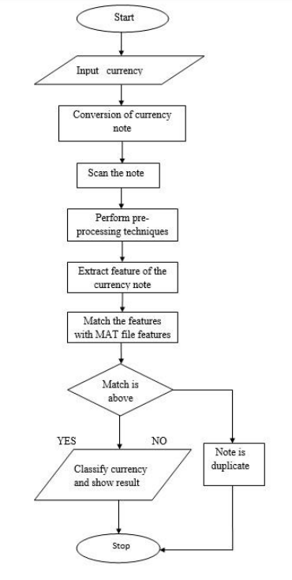

Figure 6: Flow Chart of Currency Recognisation

## 3.2.1 Image Acquisition

Because processing cannot take place until there is an image to work with, performing picture acquisition is always the first step in the sequence of work that must be done in image processing. Once the picture has been captured, a variety of processing techniques may be applied to it using a variety of methodologies in order to carry out the many different vision jobs. Image can be obtained in a number of different methods, including with the use of a camera or a scanner.

## 3.2.2 Pre-processing

This is a necessary step that must be completed before the picture processing can begin. This approach involves resizing the picture that was recorded and saving it in a standard format. The imresize function is used to do this task. After resizing the image, there is one more step that must be completed. When the image is acquired, there is a probability that it will contain noise, and the presence of noise makes the subsequent processing tasks more difficult. Consequently, in order to analyse the collected image in an appropriate manner, it is necessary to eliminate this type of noise. In this approach, the median filter is employed to get rid of the noise. Other authors could use alternative filters, but this method uses the median filter. The primary purpose of the pre-processing step is to improve the aesthetic appeal of the photographs and the ease with which the data sets may be manipulated. Image pre-processing, which is also known as image restoration, refers to the act of correcting any distortion, deterioration, or noise that may have been introduced during the imaging process. Interpolation is the method that is most commonly utilised for activities such as zooming, rotating, shrinking, and making geometric adjustments. When processing is being carried out, one of the most crucial steps is to get rid of the noise. However, noise interferes with the process of pattern matching and segmentation [7].

## 3.2.3 Conversion to Grayscale

The original image that was obtained is in RGB colour. In order to process an image in an effective manner, it is necessary to convert it into a grayscale image because this type of image carries only intensity information and is therefore simple to process. This is preferable to the alternative of processing three channels of R (red), G (green), and B (blue), which is both difficult and time consuming.

## 3.2.4 Edge Detection

It is a method for determining the borders of objects included inside photographs and is called boundary finding. Edges are sets of curved line segments that are organised according to the places at which there are significant variations in brightness. For the purpose of this approach, canny edge detection is utilised. Due to the fact that this method employs two thresholds, it is able to quickly detect strong edges in the output in addition to weak edges, provided that the weak edges are related to strong edges. In the presence of noise, the outcomes obtained using this method are superior than those obtained using the other strategy.

The stages involved in the canny edge detection are as follows:

* Applying a Gaussian filter to the image will make it smoother.

F(I,j)= G*I(I,j)

I(i,j) is the image that is being input, and G is the Gaussian filter. Where F represents the smoothed picture.

* Determine the strength of the gradient as well as its direction. When Sobel masks of size 3 by 3 are convolved with the function F, a gradient is produced in both the I and j directions.

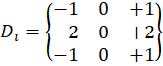 And

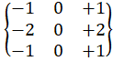

Here



and



are sobel masks in I and j direction



=



*

F



and



=



*F



and



represents

the gradients in the i direction

Now, edge strength or magnitude of gradient is given by.

(2)



=



+



Gradient direction is given by

*θ* = arctan (3)

Apply nonmaximal suppression to the magnitude of the gradient, and make use of double thresholding in order to discover and connect edge discontinuities.

The article's contents are excellent and live up to expectations. Authors have the ability to make alterations to the final manuscript; however, after the work has been submitted to the journal in its final form, alterations are no longer available.

## 3.2.5 Image Segmentation

The purpose of this phase is to streamline or alter the representation of a picture so that it may be broken down into subregions that are more actionable and simpler to examine. In order to do this, morphological operators such as erosion and dilation are used. This verifies the picture by using a tiny template known as a structuring element (a 3x3 matrix is used here), which identifies the pixel in the image that is currently being processed. The purpose of the dilation operation is to increase the size of the item by adding pixels to the edges of the object, which ultimately results in the object being larger. The input picture that has to be dilated is the first portion that the dilation process considers as data. The second part, a structural element that defines how much of the image needs to be dilated, is referred to as the kernel.

After executing the dilation process, the boundaries of the object will grow thicker. At this point, you should apply the fill operation on the picture with the parameters holes in such a manner that it automatically fills the holes of the object with various images in the image. Therefore, after performing dilation and filling the holes of the object in certain photos, the borders get mixed up; therefore, erosion is done to slightly separate the boundaries in order to make the boundaries of the objects thinner in order to provide a better output.

## 3.2.6 Feature Extraction and Comparison

One of the most challenging methods in image processing is termed "extracting features," and it requires reducing the dimensions of the data. This method is considered to be one of the most complex. When the data is too large to be processed in its whole and includes less information than it did initially, it will be transformed into a reduced representation set of features. This will take place after the data has been input. If an algorithm's input data is too large to be processed and there is a strong suspicion that it contains a great deal of redundant information, then the algorithm will transform the input data into a reduced representation set of features. This is done if there is a strong suspicion that the data contains a great deal of redundant information. The process of transforming the input data into a collection of characteristics is referred to as "extraction of features," and it is a part of data analysis. It is anticipated that the features set will extract the pertinent information from the input data in order to carry out the desired task using this reduced representation instead of the full size input if the features that are extracted are selected with care, and this is because it is expected that the features set will extract the pertinent information from the input data [7]. This is due to the fact that the reduced representation only includes the information that is pertinent to the activity at hand.

## 3.2.7 Output

The results of the currency recognition will be presented in the form of text when they have been processed. A text box on the graphical user interface (GUI) will display the output text.

Chapter 4

Result

# 4.1 Results and Discussion

For now, the system can check 100, 500, 1000, 2000, and 10000 Sierra Leonean notes. If we add more data to our database that are the currency’s primary colour, unique pattern. The system can easily check what the type and value currency is.

As soon as our system is finished, we will begin scanning more currencies for testing. According to the results of our test, it is possible to identify any kind of cash whose picture may be obtained from the scanner. And the findings suggest that they were very accurate. The image that was captured by the digital camera is not able to be identified very clearly due to the light conditions as well as other conditions. This is a challenge, but we need further time to find a solution.

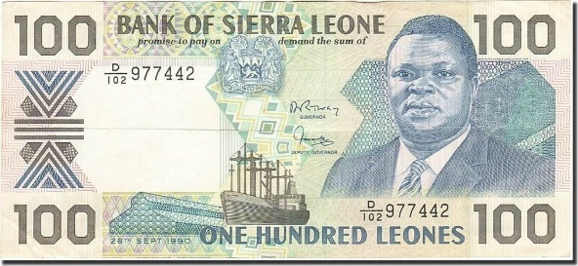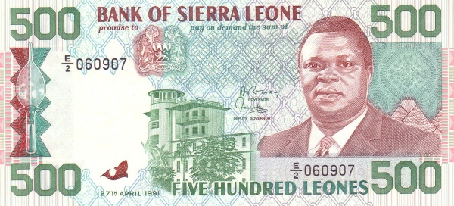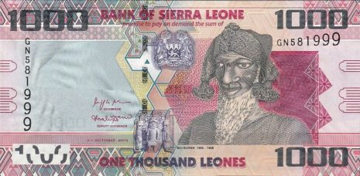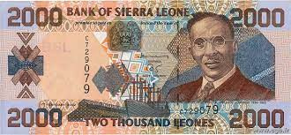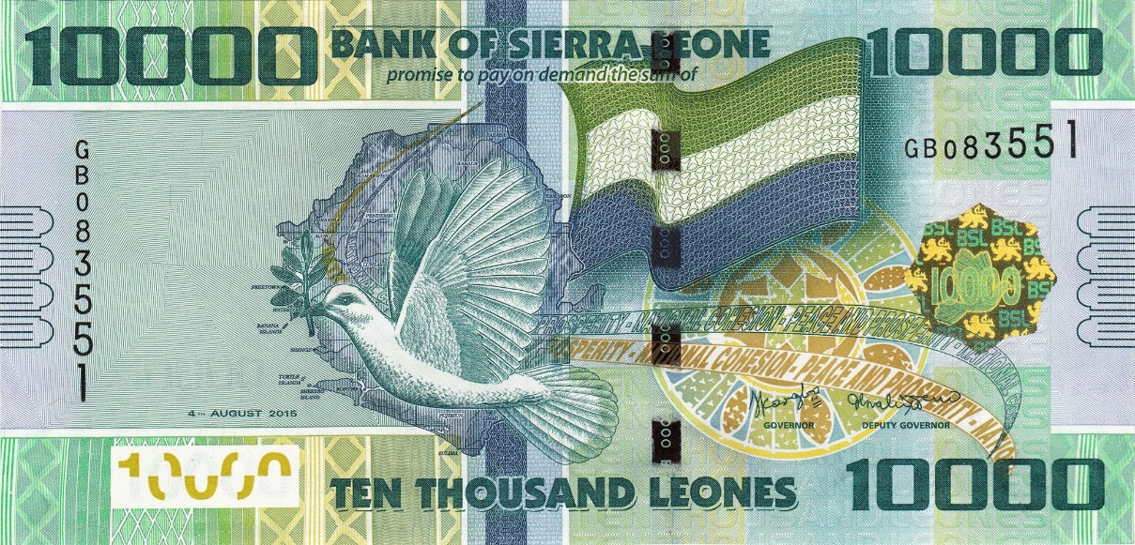

Figure 7: Sierra Leonean Notes

The figure above showing the Sierra Leonean Currency notes which we have used for the detection and recognition of the currency.

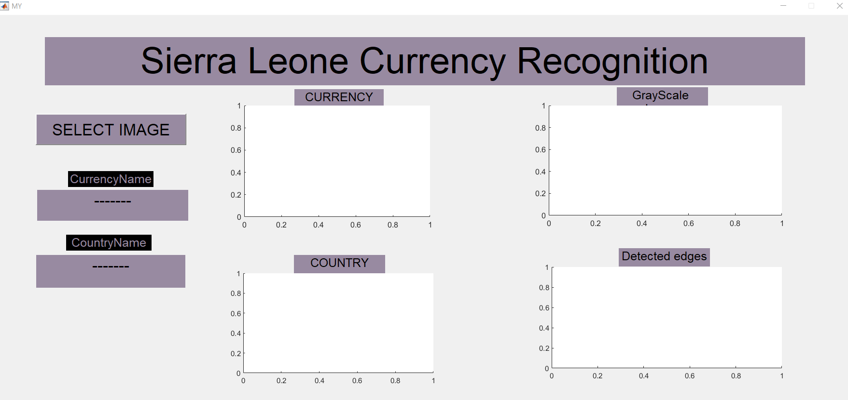

Figure 8: GUI for project

The above figure is the is the interface for the product which we have designed for the Sierra Leonean currency recognition.

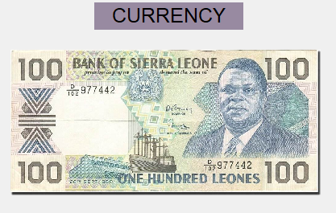

Figure 9: Loaded currency notes

The above figure show the image which is loaded in our system for the detection its means we have to detect the 100 Sierra Leonean note.

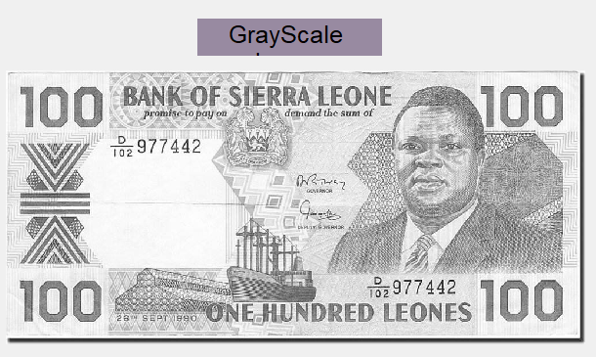

The above figure displays the details of the note in grayscale as it is the par of pre-processing the image.

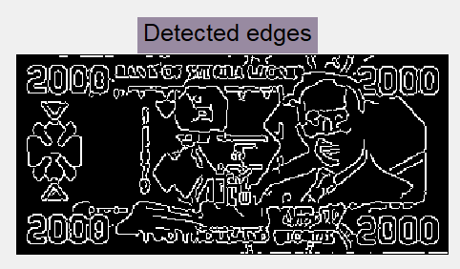

Figure 10: Edge Detection in algorithm

The above figure is showing the details of edges in the 2000 Sierra Leonean note.

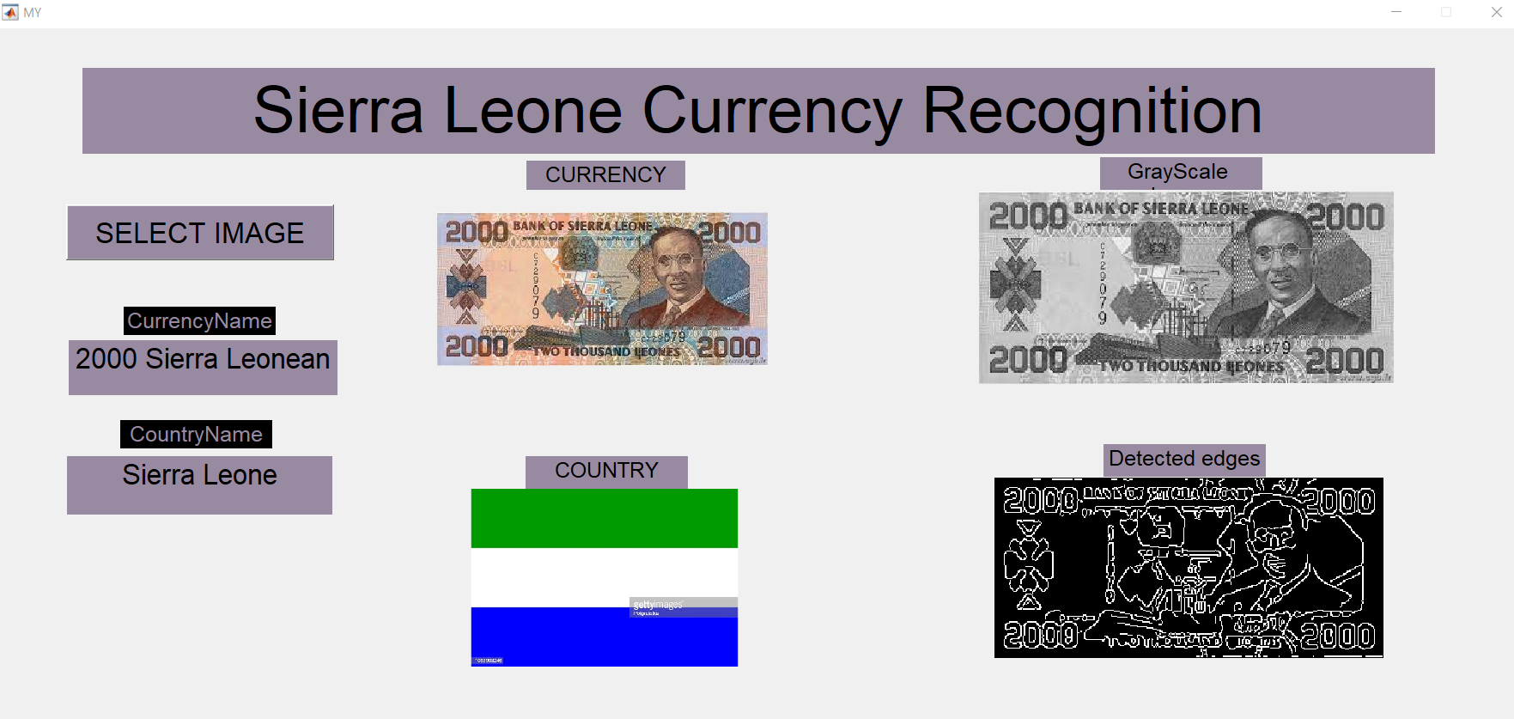

igure 11: End result of recgnition

This is the final interface and the outcome of our product and it is detecting the notes correctly by our algorithm.

The different parameter employed to differentiate between the real note and counterfeit note are observed individually as calculating mean intensity of RGB channels of both 500-currency note

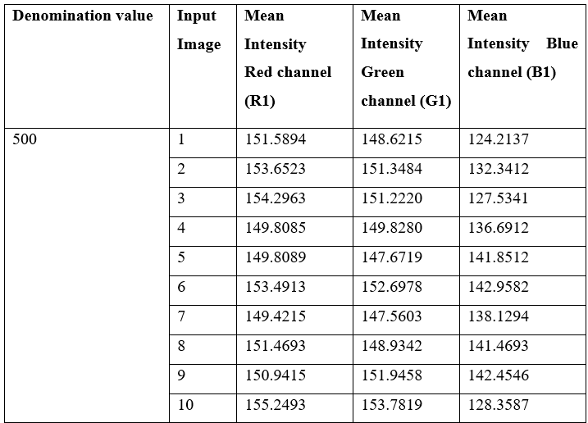

Table 1: Mean Intensity of RGB channel for different 500 note

|  |  |  |  |  |
| --- | --- | --- | --- | --- |
|  | Sierra 100 | Sierra 500 | Sierra 1000 | Total |
| Quantity | 6 | 6 | 6 | 18 |
| Success | 6 | 6 | 6 | 18 |
| Error | 0 | 0 | 0 | 0 |
| Unknown | 0 | 0 | 0 | 0 |
| Accuracy (%) | 100 | 100 | 100 | 100 |

Table 2: Banknote classification results

Table 2 illustrates the degree of accuracy that was achieved while classifying the various currencies; for instance, we tested for the Sierra Leonean notes. According to the findings in Table 2, the percentage of correct answers is rather high. This is due to the fact that we only take a few shots for testing purposes, and the remaining images come entirely from the scanner. This suggests that the lighting conditions were similar and that the images are of a high grade. If we take a digital image from the camera, as we've mentioned before, the performance will suffer, which is unfortunate. This is due to the fact that it is difficult to discriminate colours when the lighting conditions are changed. On the other hand, getting a perfect score one hundred percent of the time is quite difficult. There is a certain degree of delimitation. Characteristics essential to recognition include, among other things, the image's resolution, the surrounding lighting, and the amount of money in its previous state.

|  |  |  |  |
| --- | --- | --- | --- |
|  | Sierra 100 | Sierra 500 | Other image |
| Success | 6 | 6 | 6 |
| Fail | 0 | 0 | 0 |

Table 3: Distinguish between currency and other image

Table 3 also provided fairly respectable results. The technology can determine whether or not the image represents money. We use five more photographs in addition to those already mentioned, such as those depicting cartoons, automobiles, or some text. However, the purpose of this test is to determine whether or not the system is able to discern between different types of currency. All of the photographs are obtained through the scanner, just like in the previous experiment. The standard is quite high in this regard.

The system operates relatively efficiently thanks to these two outcomes, but with certain restrictions on its scope. The appropriate rate is quite steep. However, if we eliminate this constraint, we will not be able to achieve such a high rate of accuracy. We are working to modify our algorithm so that it can circumvent these limitations, which are the barriers that stand between us and gaining more knowledge.

## 4.1.1 Relevant

Despite the fact that the detection of currency is the primary emphasis of our thesis, the framework that we present here may also be utilised for the recognition of other things, such as a location on a map or a searching system for books (Provide the cover of the book, then search from data base).

Within the context of our methodology, the system is devised for a user who is required to discern between a number of distinct monetary payment methods. People who are blind or have other kinds of visual impairments may still be able to apply the method, but only if the results are communicated vocally rather than in written form. They are able to get the conclusion while listening through a range of output devices of their choosing.

It is so simple that all they need to do is acquire a picture of the cash, then submit it to the website, and the result will be shown on a web page. It is a really straightforward process. In addition to this, it is able to display any and all information on that currency, including the current exchange rate as well as the information. A website might potentially be used as the basis for the system's operation. It is able to assist all of the individuals who need to determine the type of cash that they possess. Getting a picture of the coin is the only thing they need to do because it is so simple for them to accomplish.

Chapter 5

Discussion and Conclusion

# 5.1 Discussion

Our system is able to read images that are given to it as input in the JPEG format, which is the format that is typically utilised (JPG). It is possible to save a picture in either the JPEG or the TIF format after it has been scanned using either a JPEG file or a TIF file. The format in which the image is stored will depend on which format was used to scan the image. Pictures saved in TIF format are remarkable for their high level of detail and good clarity, but they also have the drawback of having an excessively large capacity for storage, which is a negative. TIF pictures are famous for having these properties, despite the fact that they have this drawback. The constraint that causes a loss of information is also responsible for a decline in the amount of detail that can be stored in JPEG images. Despite this, the preserved details are sufficient for our system, and the fact that their storage capacity is quite modest is an additional bonus. Even when both images have the same resolution, the storage capacity of a TIF image is several times greater than that of a JPEG image, and in terms of the details, the details in a JPEG picture are not easily distinguishable from those in a TIF image. The storage capacity of a TIF image is several times greater than that of a JPEG image. To provide some context, even when both images have the same resolution, the amount of data that can be stored in a TIF picture is many times larger than what can be stored in a JPEG image. As a consequence of this, we have arrived at the realisation that utilising JPEG rather than TIF will provide superior outcomes in terms of efficiency. This conclusion was reached as a result of the aforementioned.

Utilizing the MATLAB® software allows us to successfully put our system into action. This is because MATLAB® is a high-level technical computer language that offers a variety of application programming interfaces (API) for image processing. The reason for this may be found in the fact that MATLAB® was developed by MathWorks. The justification behind this may be summarised as follows: In addition, the processes that are provided in MATLAB® are condensed and go straight to the point, which helps to speed up the image processing and makes it more effective in general. Real-time currency recognition will be achieved without the users having to go through any kind of time crunch, which is necessary for attaining real-time currency recognition and satisfying the standards for real-time currency recognition.

The fact that the rate of accuracy may get very close to being one hundred percent, which is a really favourable conclusion for us, comes about as a result of the numerous tests that we do on scanning images. The next phase included putting a number of photographs that were taken with a digital camera through their paces, but the results of this step ended up being completely different from what we had imagined they would be. All of these unanticipated circumstances require us to do a variety of additional processing work, such as increasing the contrast, suppressing noises, and performing more accurate segmentation, amongst other things. Different illumination conditions (under fluorescent light or under incandescent lamp), too dark and too bright, underexposure and overexposure, too many noises, and things surrounding the currency are all examples of unanticipated circumstances that require us to do this work. The unanticipated nature of these events has made it necessary to perform this additional processing effort.

# 5.2 Conclusion

The results of this study suggest that image processing might serve as the foundation for a classification system that could be used to the numerous varieties of monetary currencies. The strategy that is proposed for recognition makes use of the primary colour, in addition to a component of the currency, in order to distinguish the thing being recognised. We were able to discriminate between the different denominations of banknotes by analysing the relative levels of brightness shown by the colours red, green, and blue. Before the money may be acknowledged, this is the most important criteria that has to be satisfied. After finishing the previous step, which involved isolating the pattern from the currency, the following step consisted of using a technique called template matching to validate the currency. This was done after the completion of the previous phase. Using this method, newly printed banknotes from Sierra Leone may be recognised as having the following denominations: 100, 500, 1000, 2000, and 10000. Our method of identifying money, which is based on image processing, was found to be very quick and accurate, according to the results of the test that was run by the programme that was based on the algorithm that was mentioned earlier. This was discovered by the software that was based on the algorithm that was mentioned earlier. Having said that, a system such as this possesses a substantial number of qualities that are problematic in a variety of ways. The rate of recognition will be influenced by a number of different factors, including the quality of the sample currency and the extent to which the paper money was damaged. In spite of this, there are still certain restrictions that come along with the use of our technology, one of which being the quantity of light that is available.

# 5.3 Future Work

In the not-too-distant future, we plan to make some changes to our system, work around some of its limitations (particularly the problem that occurs when we obtain a picture from a digital camera), and finish the process of expanding our database so that it can identify additional forms of monetary value. We anticipate that these changes will take place within the next few months.

# References

|  |  |
| --- | --- |
| [1] | V. Jain, “Indian Currency Denomination Identification Using Image Processing Technique”. |
| [2] | R. a. N. Mirza, “ Paper Currency Verification System Based on Characteristic Extraction Using Image Processing. International Journal of Engineering and Advanced Technology (IJEAT),” vol. Iss 3, p. 2249 – 8958. |
| [3] | K. B. J. D. D. K. J. a. M. S. Chakraborty, “ Recent Developments in Paper Currency Recognition System. International Journal of Research in Engineering and Technology.,” Vols. 2, Iss. 11., 2013. |
| [4] | I. The MathWorks, “MATLAB and Image proccesing Toolbox Release 2019b, ., Natick, Massachusetts, United States.”. |
| [5] | P. K. G. a. K. S. Reel, “ Image processing based heuristic analysis for enhanced currency recognition. International Journal of Advancements in Technology,” vol. 2, pp. 82-89, 2011. |
| [6] | D. C. P. S. H. Pawade, “Comparative Study of Different Paper Currency and Coin Currency Recognition Method,” vol. 66, 2013. |
| [7] | H. H. a. P. M. Farahabadi., “ “Using Hidden Markov models for paper currency recognition"”. |
| [8] | M. sarasraz, “ using Radial basis functional network for classification on Intelligent paper currency recognition system,” *International Conference on Communication, Management and Information Technology,* 2015. |
| [9] | G.-B. Huang, Q.-Y. Zhu and C.-K. Siew, “ "Extreme learning machine: theory and applications".,” *Neurocomputing,* (2006). |
| [10] | B. Widrow and e. al, “ The no-prop algorithm: A new learning algorithm for multilayer neural networks,” *Neural Networks. 37: 182–188,* 2013. |
| [11] | Y. Ollivier and G. Charpiat, “Training recurrent networks without backtracking,” 2015. |
| [12] | G. E. Hinton, “A Practical Guide to Training Restricted Boltzmann Machines,” 2010. |
| [13] | A. K. R. Bhavani, “A Novel Method for Counterfeit Banknote Detection,” pp. 165-167, April 2014.. |
| [14] | A.Ms.Trupti Pathrabe and B.Dr. N.G.Bawane, “ Paper Currency Recognition System Using Characteristics Extraction and Negativity Correlated NN,” *Journal of Latest Trends in Computing.* |
| [15] | T. K. a. T. S. Yu-Ichi Ohta, “Color information for region segmentation,” *Computer Graphics and Image Processing,* pp. 222 - 241. |
| [16] | P. P. A. J. Geronimo D, “Fractal functions and Wavelet expansions based on several Scaling Function,” pp. 373-401. |
| [17] | A. F. a. P. P. M. Gori, “ A neural networkbased model for paper currency recognition and verification”. |
| [18] | M. G. a. P. P. A Frosini, “ A neural network-based model for paper currency recognition and verification,” *IEEE Transactions on Neural Networks,* vol. 7. |
| [19] | S. B. a. F. Takeda, “Proposal of Neural Recognition with Gaussian Function and Discussion for Rejection Capabilities to Unknown Currencies,",” *Knowledge-Based Intelligent Information and Engineering Systems,* pp. 859-865,, 2004. |
| [20] | B. V. &. S. D. S. Kumar, “Pattern recognition with localized gabor wavelet grids.,” *In International Conference on Computational Intelligence and Multimedia Applications,* pp. 517-521, 2007. |
| a[21] | K. Gautam, “Indian Currency Detection using Image Recognition”. |
| [22] | K. Sathisha, “Bank automation system for Indian currency-a novel approach,” *In 2011 IEEE Recent Advances in Intelligent Computational Systems,* pp. 299-302. |
| [23] | K. B. J. D. D. K. J. a. M. S. Chakraborty, “ Recent Developments in Paper Currency Recognition System. International Journal of Research in Engineering and Technology.,” Vols. 2, Iss. 11., 2013. |
| [24] | “M. Gori, A. Frosini and P. Priami. "A neural networkbased model for paper currency recognition and”. |